**Pravakar Das**

**ID:24241266**

**Task 1:**

import numpy as np

import matplotlib.pyplot as plt

#mycode="PR66" cause Name:PRAVAKAR ID:24241266

P_dzn = np.array([

[0,0, 0 , 0 , 0 , 0 , 0,0],

[0,0, 0 , 0 , 0 , 0 , 0,0],

[0,0, 255, 255, 255, 255, 0,0],

[0,0, 255, 0 , 0 , 255, 0,0],

[0,0, 255, 255, 255, 255, 0,0],

[0,0, 255, 0 , 0 , 0 , 0,0],

[0,0, 255, 0 , 0 , 0 , 0,0],

[0,0, 0 , 0 , 0 , 0 , 0,0],

[0,0, 0 , 0 , 0 , 0 , 0,0]

])

R_dzn = np.array([

[0,0, 0 , 0 , 0 , 0 , 0,0],

[0, 0, 0, 0, 0, 0, 0, 0],

[0, 0, 255, 255, 255, 255, 0, 0],

[0, 0, 255, 0, 0, 255, 0, 0],

[0, 0, 255, 255, 255, 255, 0, 0],

[0, 0, 255, 0, 255, 0, 0, 0],

[0, 0, 255, 0, 0, 255, 0, 0],

[0, 0, 0, 0, 0, 0, 0, 0],

[0,0, 0 , 0 , 0 , 0 , 0,0]

])

num6_dzn = np.array([

[0, 0, 0, 0, 0, 0, 0, 0],

[0, 0, 0, 0, 0, 0, 0, 0],

[0, 0, 255, 255, 255, 255, 0, 0],

[0, 0, 255, 0, 0, 0, 0, 0],

[0, 0, 255, 255, 255, 255, 0, 0],

[0, 0, 255, 0, 0, 255, 0, 0],

[0, 0, 255, 255, 255, 255, 0, 0],

[0, 0, 0, 0, 0, 0, 0, 0],

[0, 0, 0, 0, 0, 0, 0, 0],

])

result=np.hstack([P_dzn,R_dzn,num6_dzn,num6_dzn])

plt.imshow(result, cmap='gray')

plt.axis('off')

plt.show()

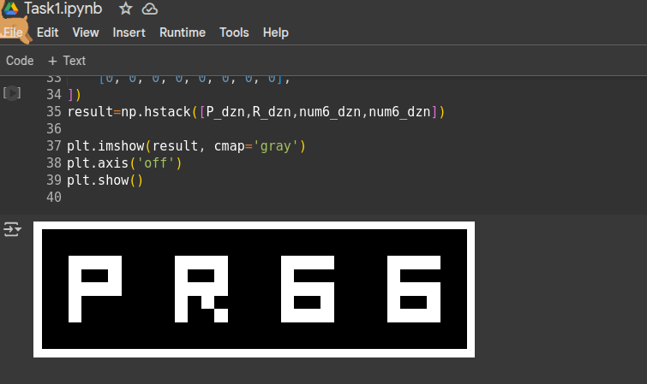

**Task 2:**

import cv2

import numpy as np

import matplotlib.pyplot as plt

import os

def crop_image(img, start_x, start_y, end_x, end_y):

# This is useful to focus on a specific area of the image by removing irrelevant parts, which can help in reducing the size of the image and focusing on key features.

return img[start_y:end_y, start_x:end_x]

def flip_image(img, flip_type):

# Flipping is a common operation in data augmentation to create variations of the image, ensuring the model becomes more robust to different orientations of objects.

return cv2.flip(img, flip_type)

def rotate_image(img, angle, scale=1.0):

# This transformation simulates the effect of objects being captured from different angles which helps improve the robustness of a model by introducing rotational variance to the training data.

rows, cols = img.shape[:2]

rotation_matrix = cv2.getRotationMatrix2D((cols / 2, rows / 2), angle, scale)

return cv2.warpAffine(img, rotation_matrix, (cols, rows))

def resize_image(img, width, height):

# By doing this, standardize all images to a consistent size, regardless of their original dimensions.

dim = (width, height)

return cv2.resize(img, dim, interpolation=cv2.INTER_AREA)

def translate_image(img, shift_x, shift_y):

# This transformation simulates small movements of the camera or object in the scene, making the model more resilient to such shifts during real-world use.

translation_matrix = np.float32([[1, 0, shift_x], [0, 1, shift_y]])

return cv2.warpAffine(img, translation_matrix, (img.shape[1], img.shape[0]))

def shear_image(img, shear_x, shear_y):

# Shearing distorts the shape of the image in a controlled manner. This simulates the effect of objects being captured from an angle or a perspective view and increases model robustness to such distortions.

rows, cols = img.shape[:2]

shear_matrix = np.float32([[1, shear_x, 0], [shear_y, 1, 0]])

return cv2.warpAffine(img, shear_matrix, (cols, rows))

def process_and_save_images(source_dir, destination_dir, resize_dimen):

for filename in os.listdir(source_dir):

if filename.endswith((".png", ".jpg", ".jpeg")):

img_path = os.path.join(source_dir, filename)

img = cv2.imread(img_path)

if img is None:

print(f"Failed to load image: {img_path}")

continue

cropped = crop_image(img, 100, 100, 277, 243)

flipped = flip_image(img, 0)

rotated = rotate_image(img, -90, 0.5)

resized = resize_image(img, resize_dimen[0], resize_dimen[1])

translated = translate_image(img, 50, 30)

sheared = shear_image(img, 0.2, 0.0)

base_name, ext = os.path.splitext(filename)

cropped_filename = f"cropped_{base_name}{ext}"

cropped_destination_path = os.path.join(destination_dir, cropped_filename)

plt.imsave(cropped_destination_path, cropped)

flipped_filename = f"flipped_{base_name}{ext}"

flipped_destination_path = os.path.join(destination_dir, flipped_filename)

plt.imsave(flipped_destination_path, flipped)

rotated_filename = f"rotated_{base_name}{ext}"

rotated_destination_path = os.path.join(destination_dir, rotated_filename)

plt.imsave(rotated_destination_path, rotated)

resized_filename = f"resized_{base_name}{ext}"

resized_destination_path = os.path.join(destination_dir, resized_filename)

plt.imsave(resized_destination_path, resized)

translated_filename = f"translated_{base_name}{ext}"

translated_destination_path = os.path.join(destination_dir, translated_filename)

plt.imsave(translated_destination_path, translated)

sheared_filename = f"sheared_{base_name}{ext}"

sheared_destination_path = os.path.join(destination_dir, sheared_filename)

plt.imsave(sheared_destination_path, sheared)  
source_dir = "/content/drive/MyDrive/CSE463-ComputerVision/24241266_PravakarDas_Lab1/Task2/SourceFiles"

destination_dir = "/content/drive/MyDrive/CSE463-ComputerVision/24241266_PravakarDas_Lab1/Task2/DestFiles"

resize_dimen = (1024, 1024)

os.makedirs(destination_dir, exist_ok=True)

process_and_save_images(source_dir, destination_dir, resize_dimen)

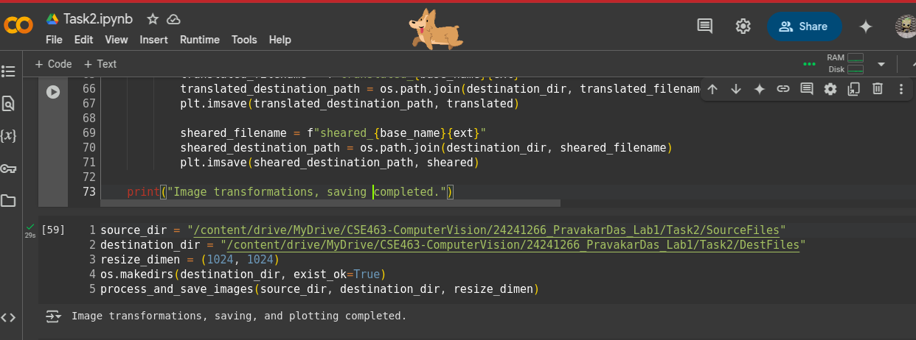

===================

def salt_and_pepper_noise(image, prob):

noisy_image = np.copy(image)

num_salt = np.ceil(prob * image.size * 0.5).astype(int) # Ensure this is an integer

num_pepper = np.ceil(prob * image.size * 0.5).astype(int) # Ensure this is an integer

salt_coords = [np.random.randint(0, i - 1, num_salt) for i in image.shape]

noisy_image[salt_coords[0], salt_coords[1]] = 255

pepper_coords = [np.random.randint(0, i - 1, num_pepper) for i in image.shape]

noisy_image[pepper_coords[0], pepper_coords[1]] = 0

return noisy_image

def gaussian_noise(image, mean=0, std=50):

noise = np.random.normal(mean, std, image.shape)

noisy_image = np.clip(image + noise, 0, 255).astype(np.uint8)

return noisy_image

def apply_noise(image, prob_salt_pepper=0.05, gaussian_std=50):

salt_pepper = salt_and_pepper_noise(image, prob_salt_pepper)

gaussian = gaussian_noise(image, std=gaussian_std)

return salt_pepper, gaussian

def plot_histograms_side_by_side(salt_pepper, gaussian, filename):

plt.figure(figsize=(20, 6))

plt.subplot(1, 2, 1)

plt.hist(salt_pepper.flatten(), bins=50, density=True, alpha=0.7, color='r')

plt.title(f'Salt-and-Pepper Histogram - {filename}')

plt.xlabel('Pixel Value')

plt.ylabel('Frequency')

plt.subplot(1, 2, 2)

plt.hist(gaussian.flatten(), bins=50, density=True, alpha=0.7, color='g')

plt.title(f'Gaussian Noise Histogram - {filename}')

plt.xlabel('Pixel Value')

plt.ylabel('Frequency')

plt.tight_layout()

plt.show()

def plot_noisy_images_with_histograms(original, salt_pepper, gaussian, filename):

fig, axes = plt.subplots(1, 3, figsize=(20, 10))

axes[0].set_title(f'Original - {filename}')

axes[0].imshow(cv2.cvtColor(original, cv2.COLOR_BGR2RGB))

axes[0].axis('off')

axes[1].set_title(f'Salt-and-Pepper Noise - {filename}')

axes[1].imshow(cv2.cvtColor(salt_pepper, cv2.COLOR_BGR2RGB))

axes[1].axis('off')

axes[2].set_title(f'Gaussian Noise - {filename}')

axes[2].imshow(cv2.cvtColor(gaussian, cv2.COLOR_BGR2RGB))

axes[2].axis('off')

plt.tight_layout()

plt.show()

plot_histograms_side_by_side(salt_pepper, gaussian, filename)

def process_images(source_dir, destination_dir, resize_dimen):

for filename in os.listdir(source_dir):

if filename.endswith((".png", ".jpg", ".jpeg")):

img_path = os.path.join(source_dir, filename)

img = cv2.imread(img_path)

if img is None:

print(f"Failed to load image: {img_path}")

continue

img_resized = cv2.resize(img, resize_dimen)

salt_pepper, gaussian = apply_noise(img_resized)

base_name, ext = os.path.splitext(filename)

salt_pepper_filename = f"salt_pepper_{base_name}{ext}"

salt_pepper_path = os.path.join(destination_dir, salt_pepper_filename)

plt.imsave(salt_pepper_path, cv2.cvtColor(salt_pepper, cv2.COLOR_BGR2RGB))

gaussian_filename = f"gaussian_{base_name}{ext}"

gaussian_path = os.path.join(destination_dir, gaussian_filename)

plt.imsave(gaussian_path, cv2.cvtColor(gaussian, cv2.COLOR_BGR2RGB))

plot_noisy_images_with_histograms(img_resized, salt_pepper, gaussian, filename)

print("Image noise transformation, saving, plotting, and histogram display completed.")

source_dir = "/content/drive/MyDrive/CSE463-ComputerVision/24241266_PravakarDas_Lab1/Task2/SourceFiles"

destination_dir = "/content/drive/MyDrive/CSE463-ComputerVision/24241266_PravakarDas_Lab1/Task2/DestFiles"

resize_dimen = (1024, 1024)

os.makedirs(destination_dir, exist_ok=True)

process_images(source_dir, destination_dir, resize_dimen)

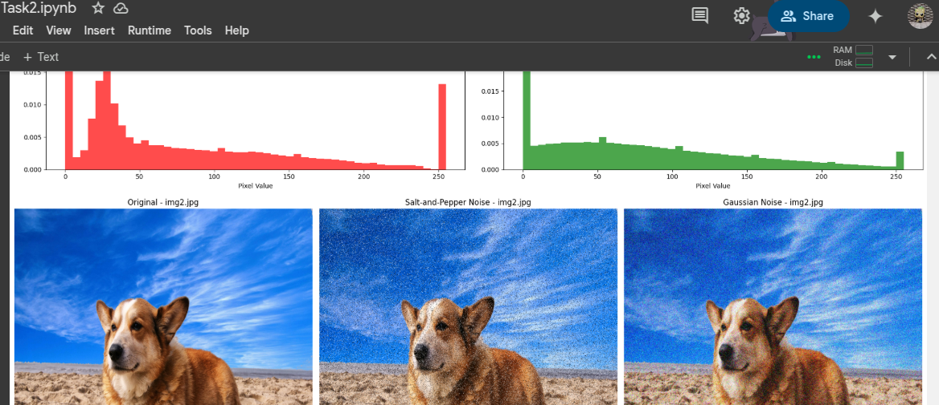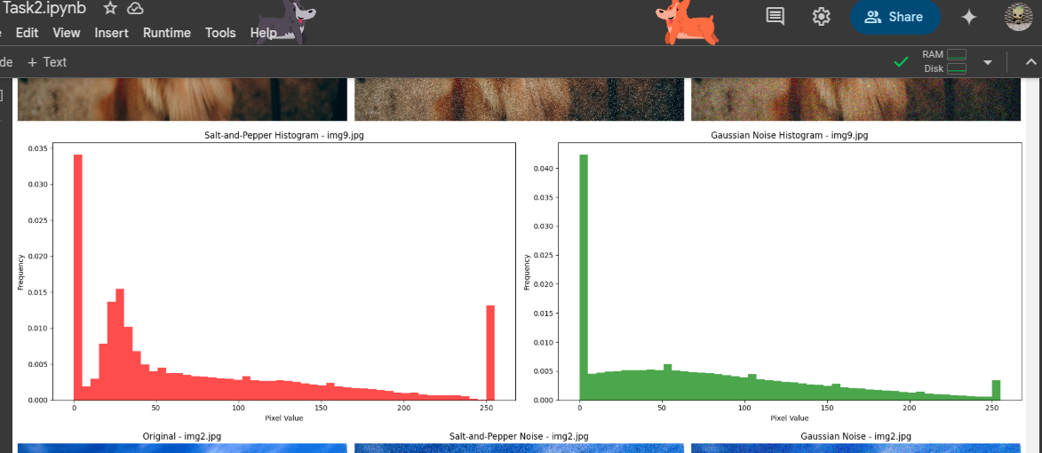

**Task 3:**

import cv2

import os

import numpy as np

import matplotlib.pyplot as plt

def load_and_convert_images(source_dir):

image_filenames = [f for f in os.listdir(source_dir) if f.endswith(('.jpg', '.jpeg', '.png'))]

images_rgb = []

for filename in image_filenames:

img_bgr = cv2.imread(os.path.join(source_dir, filename))

img_rgb = cv2.cvtColor(img_bgr, cv2.COLOR_BGR2RGB)

images_rgb.append(img_rgb)

return images_rgb

def resize_images(images_rgb, width=2048, height=2048):

images_resized = []

for img in images_rgb:

dim = (width, height)

img_resized = cv2.resize(img, dim, interpolation=cv2.INTER_AREA)

images_resized.append(np.uint8(img_resized))

return images_resized

def blend_images(images_resized, alpha_values=None):

if alpha_values is None:

alpha_values = [0.2] * len(images_resized)

blended_image = images_resized[0] * alpha_values[0]

for i in range(1, len(images_resized)):

blended_image = np.uint8(blended_image)

current_image = np.uint8(images_resized[i])

blended_image = cv2.addWeighted(blended_image, 1 - alpha_values[i], current_image, alpha_values[i], 0)

plt.imshow(blended_image)

plt.title("Blended Image")

plt.show()

return blended_image

def save_image(image, output_path):

cv2.imwrite(output_path, cv2.cvtColor(image, cv2.COLOR_RGB2BGR))

source_dir = "/content/drive/MyDrive/CSE463-ComputerVision/24241266_PravakarDas_Lab1/Task3/SourceFiles"

destination_dir = "/content/drive/MyDrive/CSE463-ComputerVision/24241266_PravakarDas_Lab1/Task3/DestFiles"

images_rgb = load_and_convert_images(source_dir)

images_resized = resize_images(images_rgb)

alpha_values = [0.25, 0.25, 0.2, 0.15, 0.15]

blended_image = blend_images(images_resized, alpha_values)

output_path = os.path.join(destination_dir, "blended_image.jpg")

save_image(blended_image, output_path)

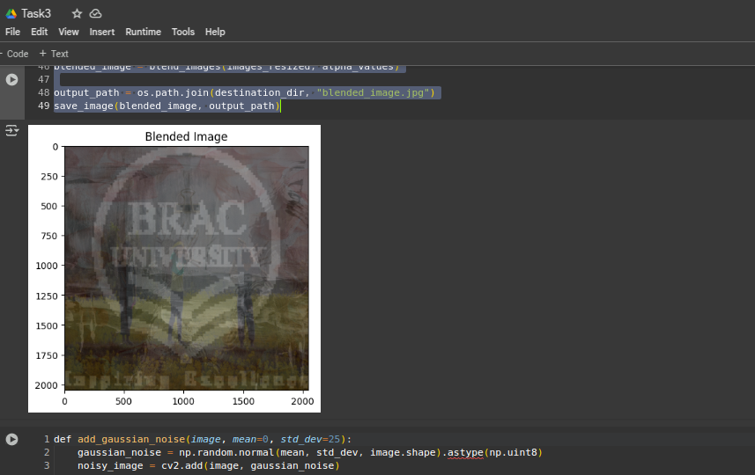===========================================

def add_gaussian_noise(image, mean=0, std_dev=25):

gaussian_noise = np.random.normal(mean, std_dev, image.shape).astype(np.uint8)

noisy_image = cv2.add(image, gaussian_noise)

noisy_image = np.clip(noisy_image, 0, 255)

return noisy_image

def display_before_after(original_image, noisy_image):

plt.figure(figsize=(12, 6))

plt.subplot(1, 2, 1)

plt.imshow(original_image)

plt.title("Original Image")

plt.axis('off')

plt.subplot(1, 2, 2)

plt.imshow(noisy_image)

plt.title("Image with Gaussian Noise")

plt.axis('off')

plt.show()

noisy_blended_image = add_gaussian_noise(blended_image, mean=0, std_dev=25)

display_before_after(blended_image, noisy_blended_image)

output_noisy_path = "/content/drive/MyDrive/CSE463-ComputerVision/24241266_PravakarDas_Lab1/Task3/DestFiles/noisy_blended_image.jpg"

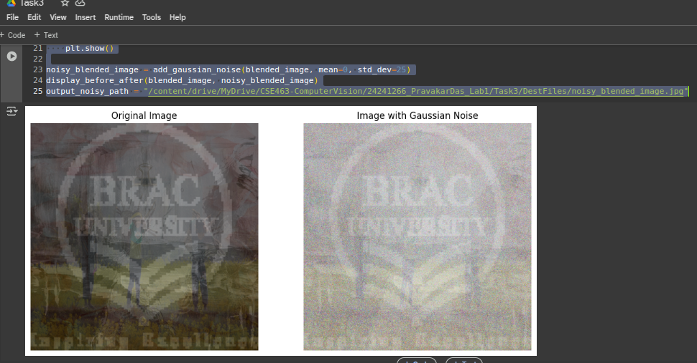

==================================================

mean = 0

std_dev = 1

num_samples = 100000

gaussian_noise = np.random.normal(mean, std_dev, num_samples)

plt.hist(gaussian_noise, bins=50, density=True, alpha=0.6, color='g')

plt.title('Generated Gaussian Noise')

plt.xlabel('Value')

plt.ylabel('Frequency')

plt.grid(True)

plt.show()

image = cv2.imread('/content/drive/MyDrive/CSE463-ComputerVision/24241266_PravakarDas_Lab1/Task3/DestFiles/noisy_blended_image.jpg')

